**DBMS ASSIGNMENT 14**

**CLASS: TE B**

**ROLL NO: 322008**

**Problem Statement:** Implement MYSQL/Oracle database connectivity with PHP/ python/Java Implement Database navigation operations (add, delete, edit,) using ODBC/JDBC.

**Screenshots:**

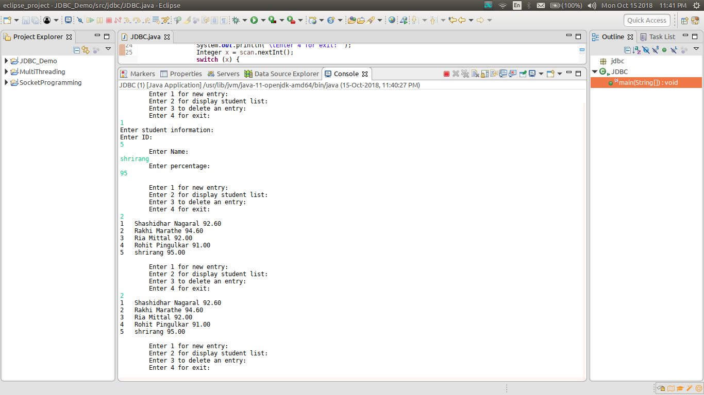

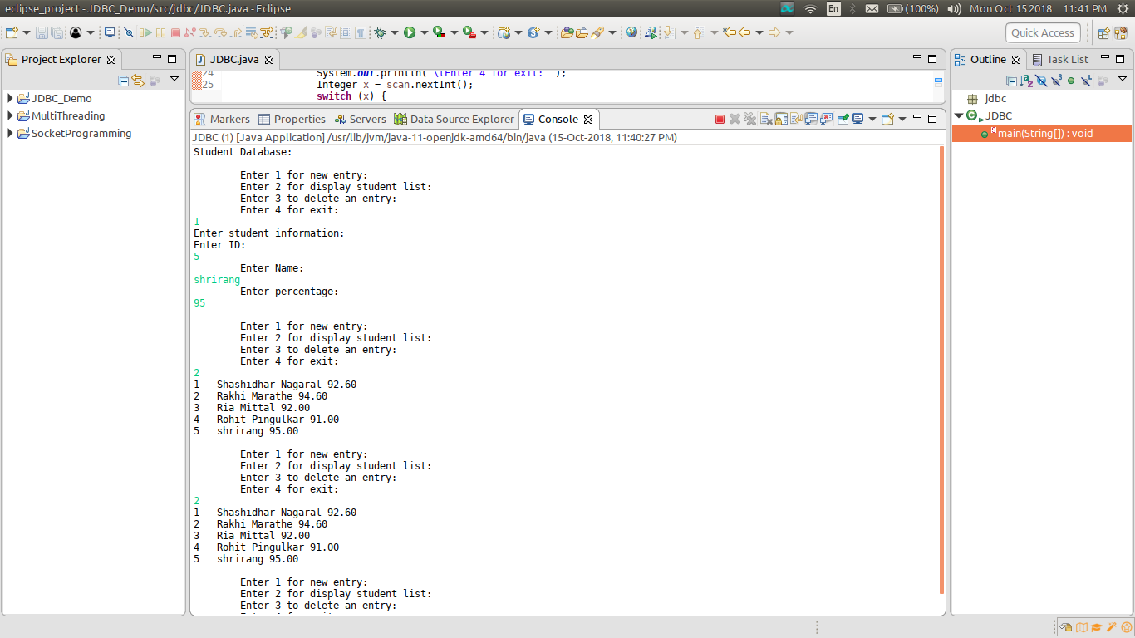

**Conclusion:** Jdbc connectivity was implemented successfully.